
LOTUS ELITE ASSOCIATION of DRIVERS, FOLLOWERS, OWNERS, OPERATORS, TINKERERS and SUCHLIKE

29th July, 2003

LEADFOOTS luncheon

It has been brought to my attention that we are overdue for another LEADFOOTS gathering.
So to alleviate any further agitation and avoid potential uprisings, a date has been established for our next luncheon.

The traditional venue at the Casa Bella Italian Restaurant, 172 Victoria Avenue, Chatswood, is again the meeting place for 12.30pm. And you need to be there on:

Tuesday, 23rd September.

This date is after the Historic race meeting at Eastern Creek earlier in the month, so all the stories and excuses should be well embellished by then. Our overseas guest on this occasion will be Ray Edwards from New Zealand, who has bravely put up his hand as editor of the long established Club Elite newsletter. A heroic move, but I am sure he will need help and guidance on the day, so don’t be backwards in coming forwards.

It should again be another classic occasion of good company, good conversation and good food.
We keep getting bigger each gathering, and the restaurant now opens specifically to cater for us, so it really is important that you let me know your intentions as soon as possible. Recalcitrants will be mentioned - and doubtless discussed over the pasta.

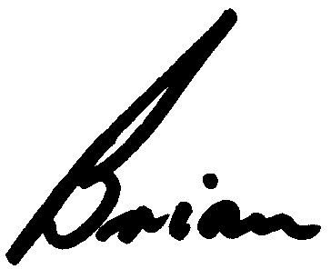
See you there,

Brian Caldersmith

18 Burnley Ave
North Turramurra 2074
Ph: 9449 1740
Fax: 9402 5740
Mobile: 0401 927 275
E-mail: BrianTC@bigpond.com

